April's Tea House

About: handshake tea related beverage. You can enjoy the wonderful Asian tea and delicious Boba. Maybe you have already drunk tea, but after handshaking, they give these beverages a new taste. Come in and have something to drink, don’t hesitate.

Business time: 1~6pm

<https://www.yelp.com/biz_photos/aprils-tea-house-corvallis>

Black Tea 3

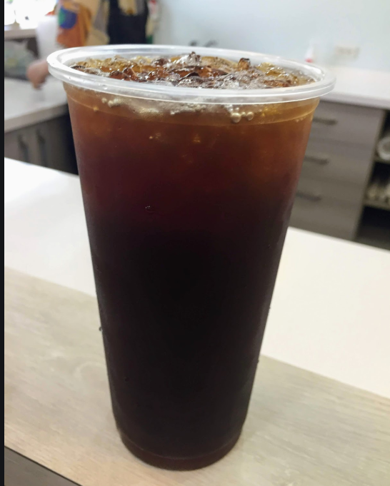

Green Tea 3

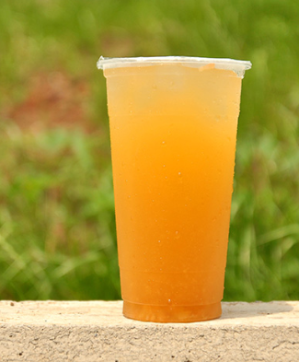

Golden Phoenix 3

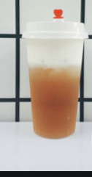

Jasmine Tea 3

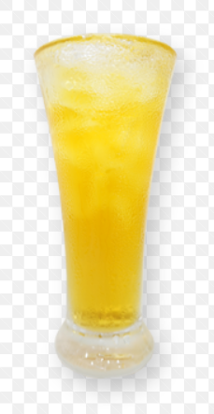

Lychee Black Tea 3

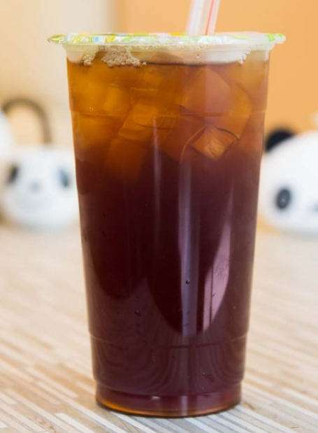

Milk Tea 4.5

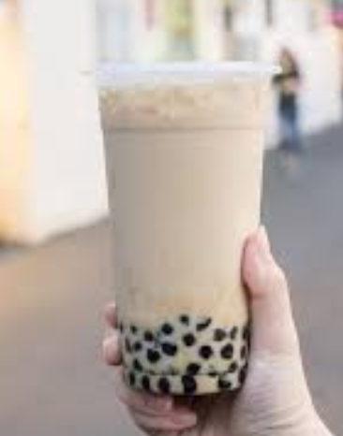

Oreo Milk Tea 4

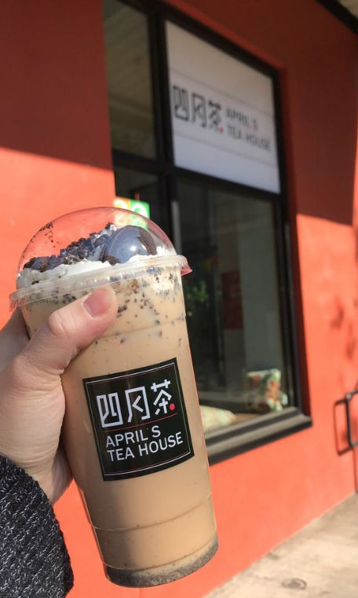

Black Sugar Boba Milk 4.75

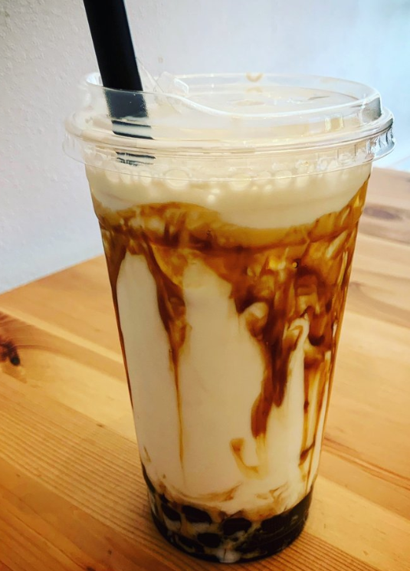

Pineapple Slush 4.95

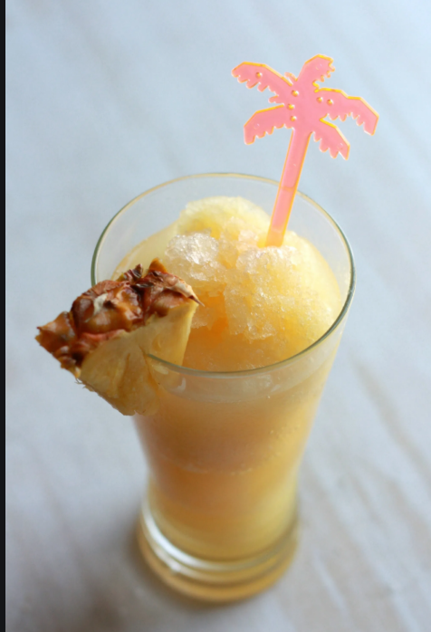

Matcha Milk Tea 4.00

